Altimetrik Technical Assessment

This assessment is designed to evaluate candidate’s technical skills and identify candidate’s strongest points.

The assessment consists of two parts:

1. Reviewing the Assessment: approximately 10 minutes. The candidate will be given the assessment and left alone to review it. The candidate may make notes and start designing the solution during this time. At the end the candidate may ask questions about the assessment to clarify what is required, before starting to implement their solution.
2. Coding: 3 hours. The candidate will implement web application based on the provided requirements. The task is designed to evaluate the candidate’s expertise as well as assess the time management skills and ability to read and understand technical documentation. If the application is not finished on time, the task *will not be considered a failure*. If the candidate is able to fully complete the task, any additional functionality will be considered as bonus points.

## Use Case

## Election Management System

Election commission of India wants to conduct parliament election due to current ruling Government period going to end on Apr 2024. As part of the digital transformation program, Election commission wants to manage election duties online. Assume that for the current election there is no individual contestant, any candidate participating in the election should belong to a party.

Below are the some of the use cases for election commission wants to go digital.

1. Number of MP seats in each state

2. Registered Party Name and their symbols

3. Master data for party symbols

4. Voter list

5. List of candidates who are contesting in the election from registered party

6. Voting System

7. Election result

## Use Case Details

1. Number of MP seats in each state

* Election commissioner can increase and decrease number of MP seats in a state.
* Election commissioner can view the list of MP seats along with states.

2. Registered Party name and their symbols/Master data for party symbols

* Election commissioner can register a party name and allot symbols from master data.

3. Voter’s List

* Any Voter can register himself for voting (Voter id, Name, Address, and Photo), Election Commissioner should approve the registered voter, and then only voter is eligible for voting else voter is not eligible.

4. List of candidates who are contesting in the election from registered party

* Election commissioner can register candidate who are participating in the election along with the party name and state.

5. Voting system

* Election commissioner can create a voting system with list of candidates along with party symbol (radio button for each candidate and submit)
* Voters can login into the system and vote for the candidate. Voter is allowed to vote for once.

6. Election Result

* Election Commissioner can view result (number of votes for each party) and which party has more majority.

## Use Case Diagram for Election Management System

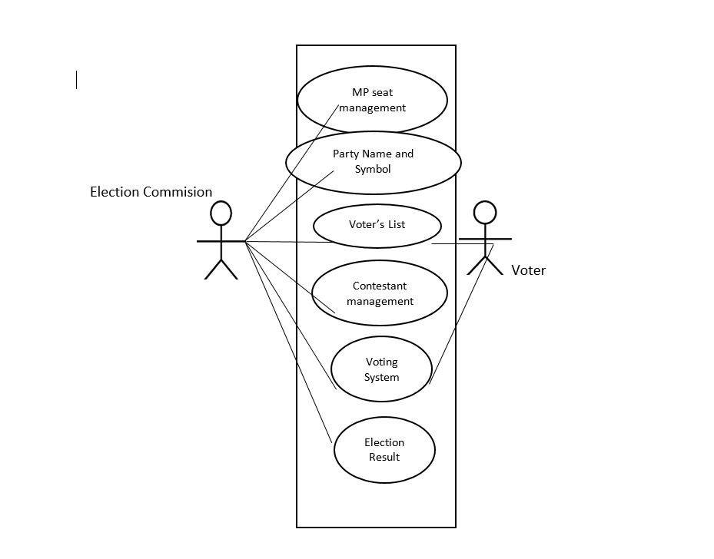

You have been asked by your team manager to implement the prototype. Please refer to the above mentioned Use Case.

The prototype can be implemented as

* ASP.NET Core Web App (.NET6 OR .NET7)
* ASP.NET Core Web API (.NET6 OR .NET7)
* Database (SQLLite or any other equivalent lightweight DB)

**Technology Stack:**

* Application Server and Restful APIs using
  + ASP.NET Core (6, 7)
* HTML5
* Css3
* Database (lightweight SQL database like SQLLite)

Submitted Exercises will be evaluated on following criterions:

* Performance and scalability
* Usage Design principles/patterns
* Coding best practices/standards

Acceptance Criteria

* UI Components should interact with back-end Restful APIs;
* No Runtime Exceptions

## Deliverables

At the end of the coding test we will require the following artefacts for evaluation - **hosted on an accessible Git (Github/Bitbucket) repository**.

* The full source code of the application
* A human readable export file of the database, which has to contain the schema and some data

## Helpful Tips

* We are developers, so we will be looking for good development practices in your solution. Select the technologies you are most comfortable with, aim at showing your best skills, rather than experimenting new technologies.
* The time limit is shorter than you think, so focus on getting the application to work first, and then add extras afterwards.
* You will be assessed based on your skill (expertise) level.